**Weboldal ötlet:**

Egy vintedhez hasonló weboldal, csak könyvekkel. Az oldalon a felhasználók egymás között adhatják el a könyveiket, pontos leírást adva hozzá (fülszöveg, állapot, oldalszám, képek). Ugyanúgy lenne lehetőség alkudni is a termékből, illetve privátban beszélgetésben akár mégtöbbet megtudni az adott termékről.

Promptok és képek:

* Webdesign: beautiful book for sale website, ui, ux, ui/ux, website, brown, beige, cream colour

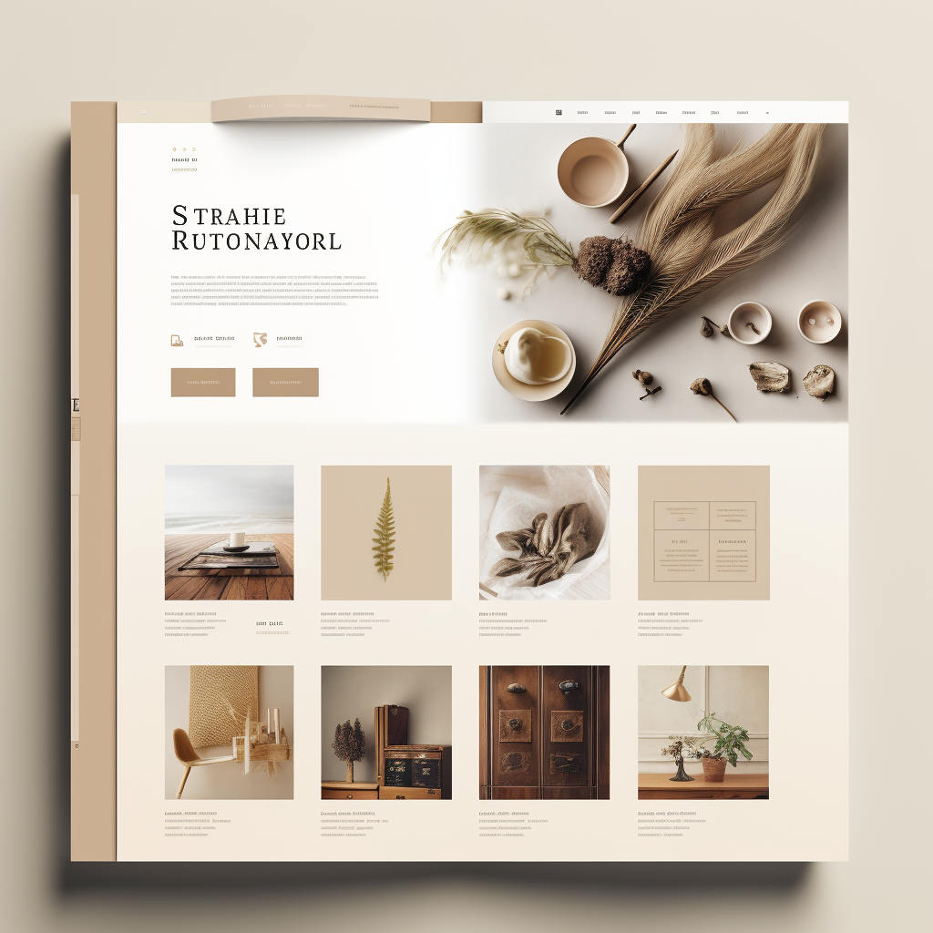

* Logo: beautiful book website logo, animation



* Elso_kep: The Planet of Time, Modern and technical visuals characteristic of the sci-fi genre, featuring futuristic designs and complex time-travel effects, Exploration of time travel, paradoxes, and scientific theories, balanced with characters' emotions and choices, Authentic representation of futuristic cities and historical periods, emphasizing technological and cultural differences, Evolution of time travel technology and its impacts on the world, central to the story, Skillful tension between choices, losses, and victories in the context of the past and future

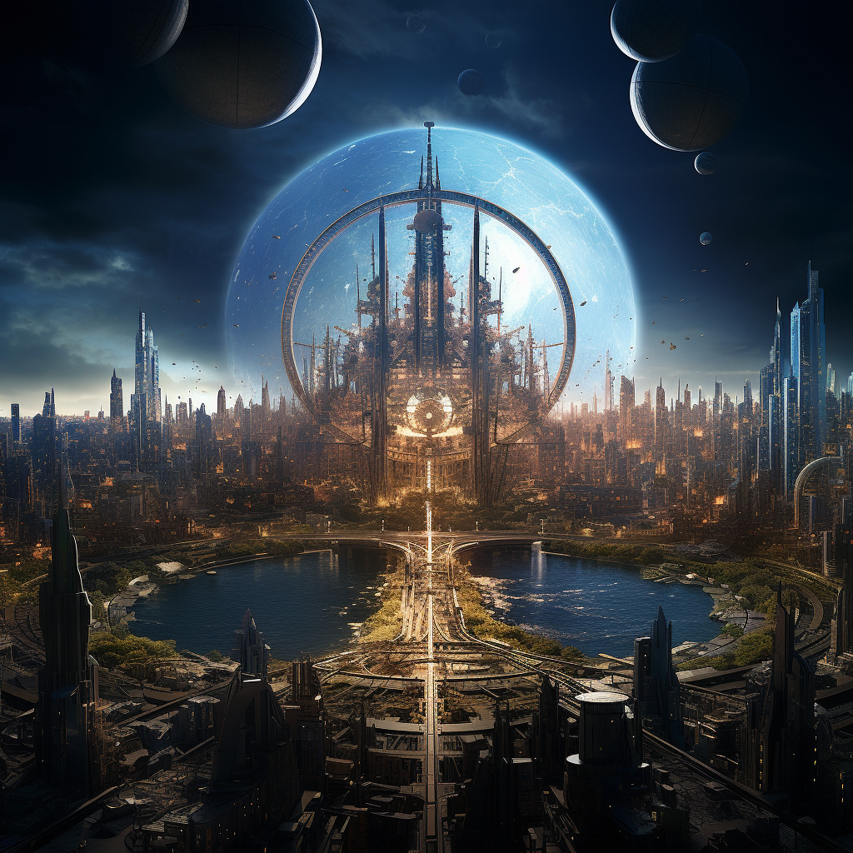

* Masodik_kep: The Cathedral, Artistic depiction with realistic historical details, highlighting the richness of medieval architecture and art, Detailed presentation of medieval architecture and society, woven around the drama of cathedral construction and characters' destinies, Authentically portrayed artificial medieval towns, construction sites, and natural environments, Political, religious, and cultural backdrop of the medieval period influencing characters' decisions and relationships, Profound religious and historical reverence pervading the construction process and people's lives

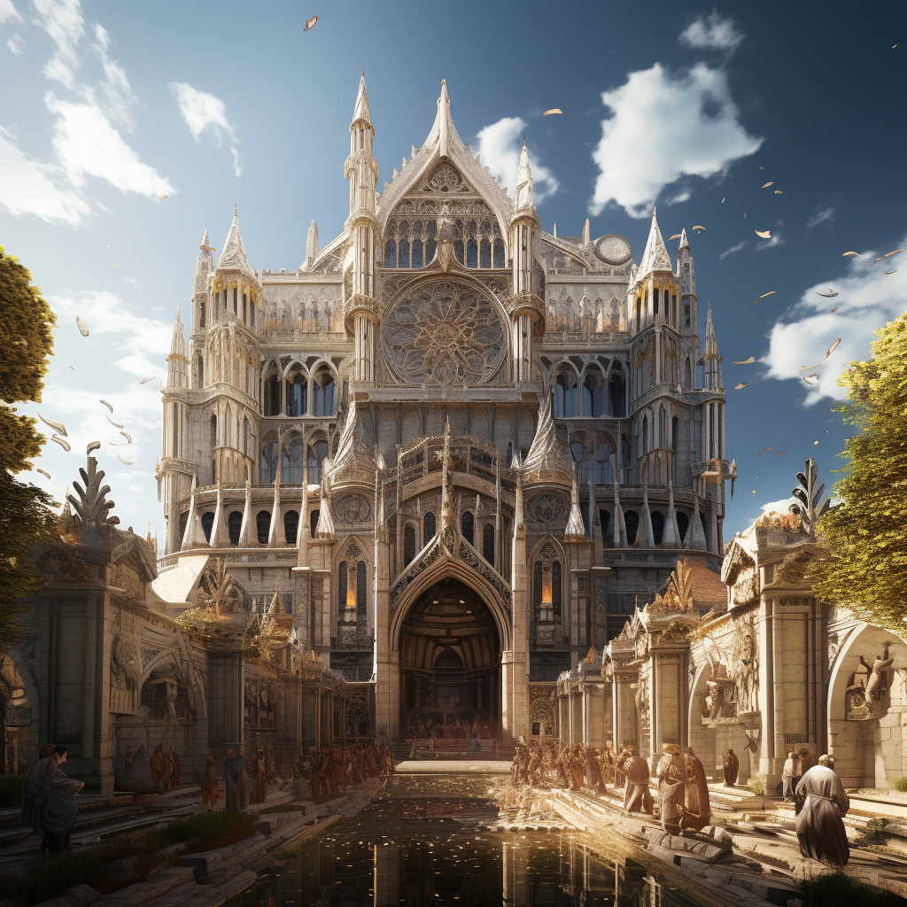

* Harmadik_kep: Harry Potter and the Philosopher's Stone, Magical, colorful, and detailed illustrations bringing the world of magic and mysticism to life, A boy's journey into the world of magic, exploring friendships, and dangers at Hogwarts School of Witchcraft and Wizardry, Mysterious corridors of Hogwarts, wizards' shops, dark forests, and homes of magical creatures, Mysterious history of the wizarding world and the dynamics between people and magic, Awe and excitement as the boy discovers a completely new and astonishing world

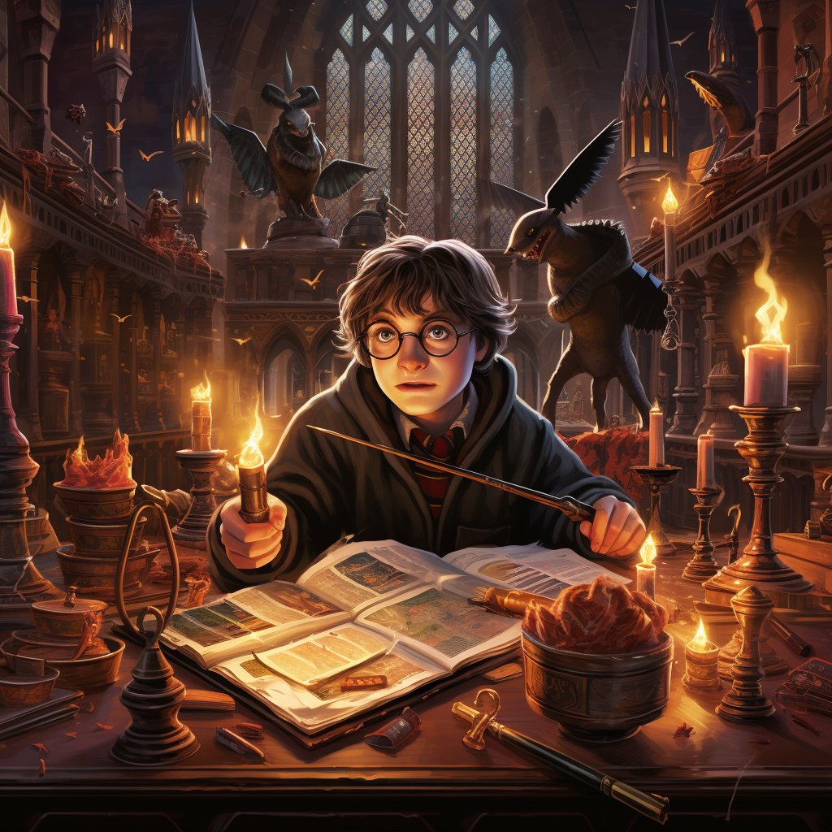

* Negyedik_kep: The Lost Prince, High fantasy and epic genre style, showcasing wondrous creatures and grand landscapes, Hero's quest for the lost throne and to defeat eternal darkness, featuring massive clashes and internal conflicts, Realistic depiction of magical kingdoms, ancient ruins, snow-covered peaks, and dark dungeons, Creation of the magical world, ancient legends, and the interplay between people's stories and fate, Vast-scale adventure and the struggle between light and darkness, presented in an exciting and dramatic manner

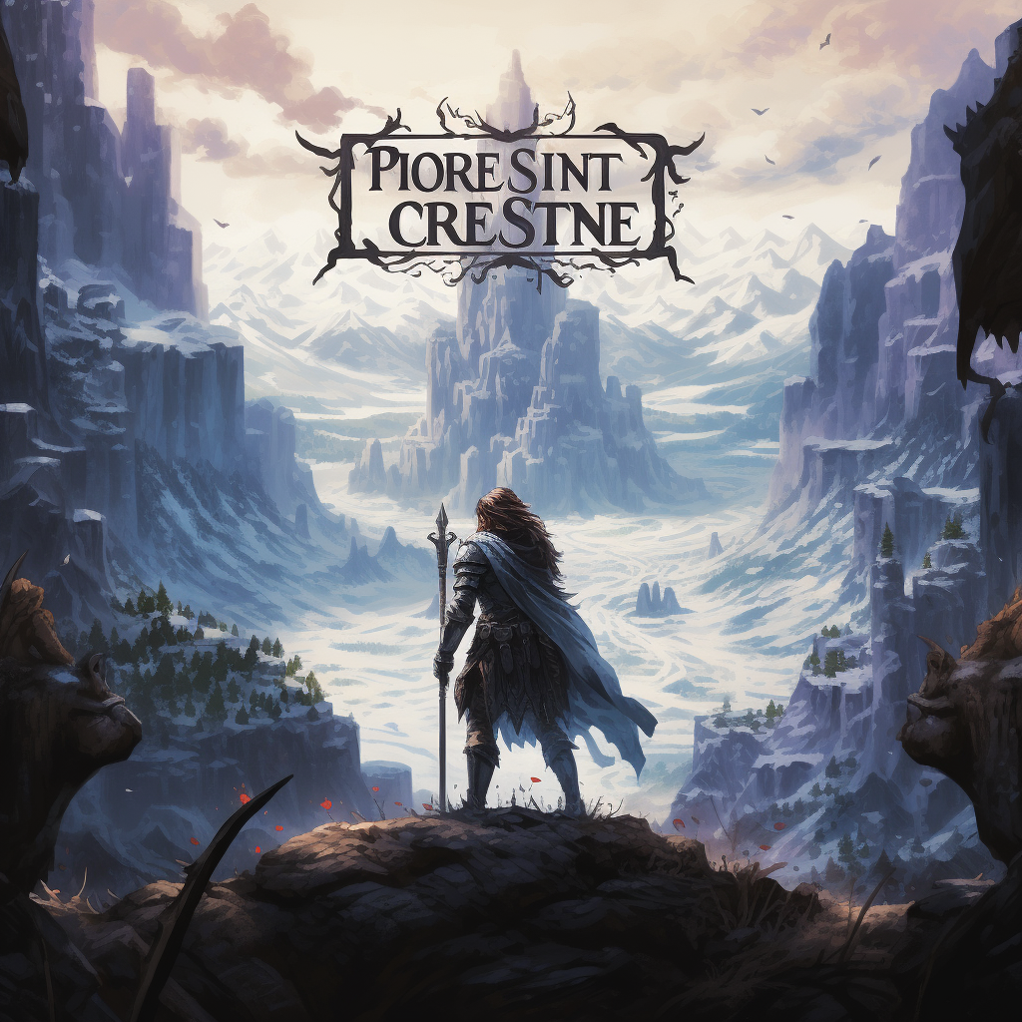

* Otodik_kep: The Handmaid's Tale, Design with oppressive and gray tones, highlighting the importance of survival and resistance, Fate of a female character in an oppressive society where women are servants, exploring the path towards rebellion, Dark and tightly controlled environment of handmaids, where power suppresses the weak, Factors leading to the creation and maintenance of the oppressive system, and the influence of characters' past on the present, Tense and bleak ambiance, illuminated by the courage and perseverance of female characters

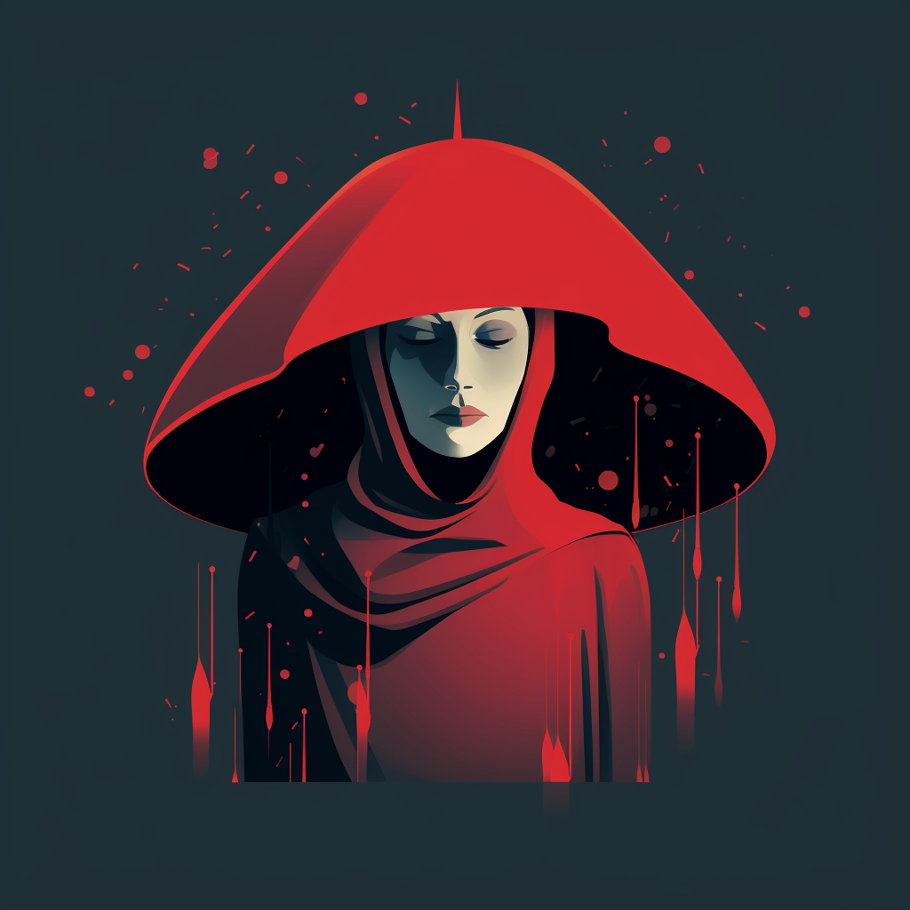

* Hatodik_kep: The Lord of the Rings, Fantastic and grandiose illustrations, rich in details of the fantasy world and captivating creatures, Epic journey of heroes embarking on a perilous quest to destroy the lost ring in a fantasy world, Realistic portrayal of various realms, dark forests, mountain peaks, and desolate wastelands, Creation of the world, various races, and intricate history shaping the characters' decisions, Astonishing and immersive environment, capturing the allure and peril of a fantastical adventure

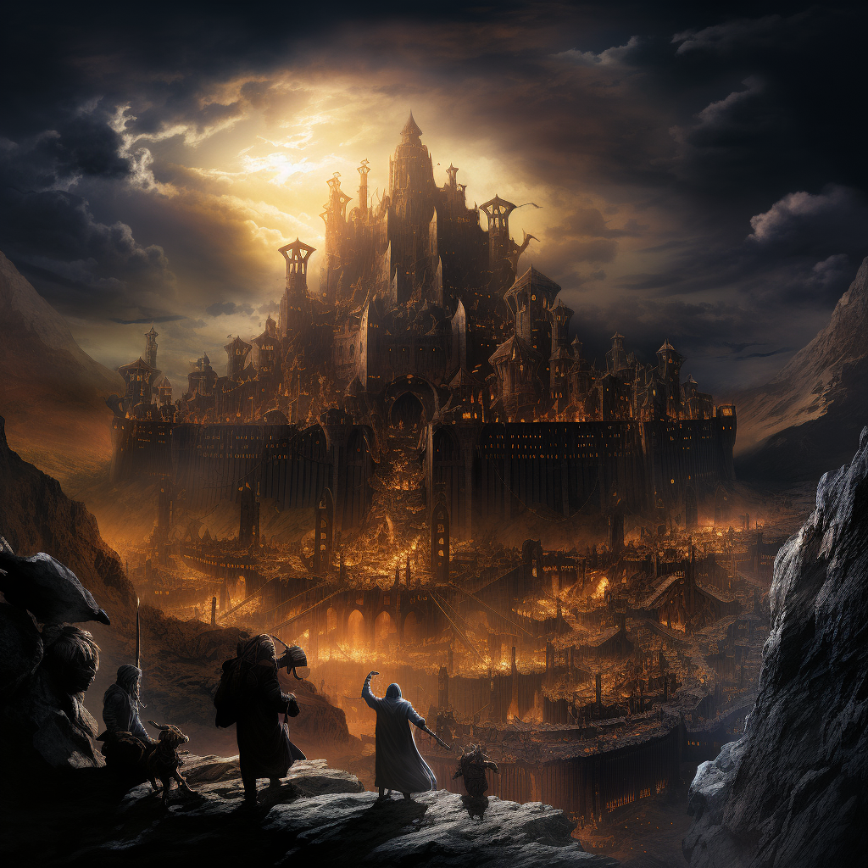

* Hetedik_kep: Stoner, Subtle and introspective visuals capturing the nuances of the protagonist's life journey, using muted tones and delicate details, An emotionally resonant biographical novel, following a man's search for his place between academic life and love, Authentic depiction of university campuses, urban landscapes, and intimate interiors, reflecting the character's changing environment, Exploration of the protagonist's life choices against the backdrop of societal changes and personal challenges, A reflective atmosphere pervading the narrative, inviting readers to contemplate the choices and meaning in one's life

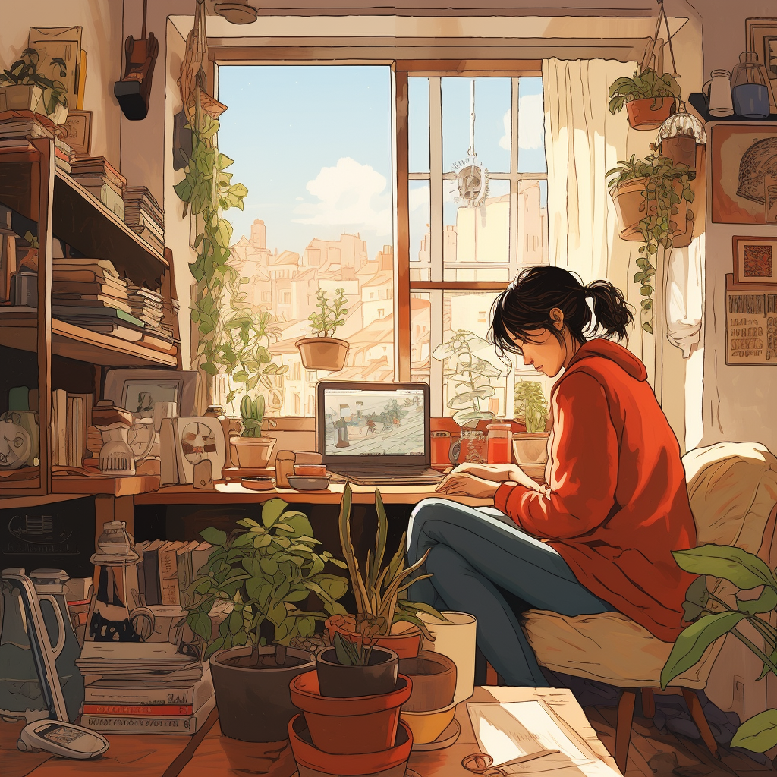

* Nyolcadik_kep: The Alchemist, Mystical and symbolic imagery, utilizing warm and golden tones to evoke a sense of spiritual discovery, Philosophical novel centered around finding one's purpose and the importance of embarking on personal quests, Enigmatic desert landscapes, vibrant marketplaces, and ancient ruins, mirroring the protagonist's journey of self-discovery, A blend of folklore, spiritual teachings, and philosophical ideas that shape the protagonist's transformative journey, A meditative and introspective atmosphere resonating with the protagonist's pursuit of his own "Personal Legend

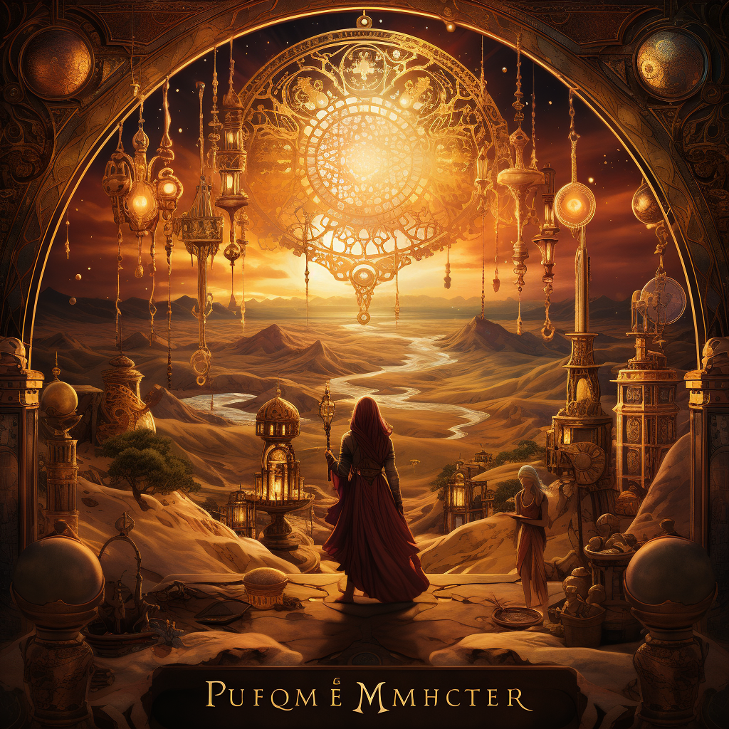

Weboldal, ahogyan nálam nézett ki: A kész weboldalon összecsúsztak a dolgok ://

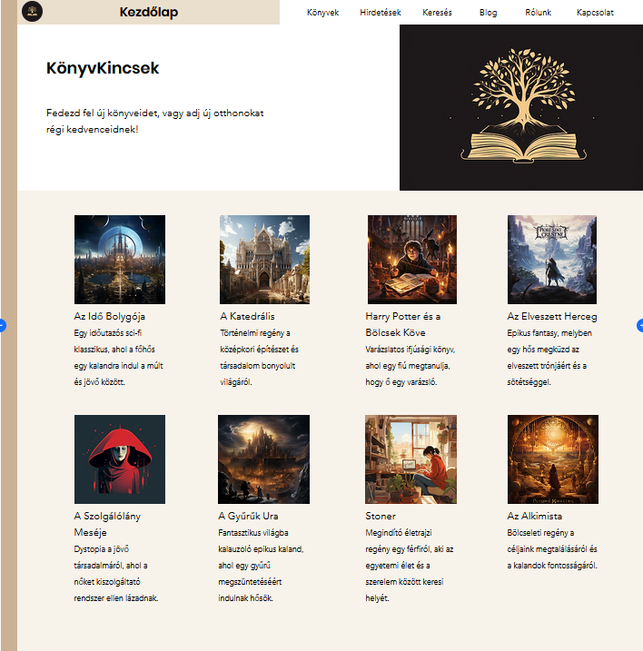

Weboldal linkje: <https://mayerhedda.editorx.io/konyvkincsek>

ChatGPT beszélgetés: <https://chat.openai.com/share/691f7378-c457-4c3f-9c48-60bc20672bcb>

SEO kulcsszavak:

1. Könyvpiac
2. Használt könyvek
3. Könyv vásárlás és eladás
4. Használt regények
5. Könyv csere
6. Irodalmi kincsek
7. Könyv cserélődés
8. Régi könyvek eladása
9. Vintage könyvesbolt
10. Olvasó közösség
11. Ritka könyv felfedezések
12. Gyűjteményes irodalom
13. Előzőleg szeretett regények
14. Regény piac
15. Irodalmi akciók
16. Könyvgyűjtők
17. Használt olvasmányok
18. Könyvesbolt piac
19. Irodalmi hirdetések
20. Régi könyv ajánlatok
21. Antikvárium
22. Könyv cserélés
23. Előzőleg birtokolt irodalom
24. Vintage regények
25. Irodalmi felfedezések